['26 FE] Improving Boot Performance and Data Reliability in Telematics Configuration Service

About This Document

Document Information
Document Title | SW Design
Project | 24DCM SU
Issuing Authority | Toyota
Author | Dao Ba Luong (luong.dao@lge.com)
Status of Document | Completed

Revision History
Version | Date | Content of Change | Author | Reviewer
01 | 2025.09.17 | Initial Release | luong.dao | by.kim

Contents
1. Introduction 6
1.1. Purpose 6
1.2. Audience 6
1.3. Abbreviations / Terms 6
1.4. Related Documents 7
2. Project Context 8
2.1. Software Context 8
2.2. Software Architectural 8
2.3. Background 9
3. Problem Defined 11
3.1. Functional Requirements 11
3.2. Problem Identification 11
3.2.1. Problem Description 11
3.2.2. Problem Analysis 13
3.3. Quality Attributes 16
4. Architecture Alternatives 17
4.1. Database structure alternatives for Configuration Service 17
4.1.1. Proposal 1 – LSMDB mechanism (Log-Structured Merge Database) 17
4.1.2. Proposal 2 –Lightning Memory-Mapped Database mechanism 19
4.1.3. Proposal 3 – SQLite 20
4.1.4. Comparison and decision 23
4.2. Design for Dynamic Thread Pool 24
4.2.1. Proposal 1: Direct Integration 24
4.2.2. Proposal 2: Generic Interface Design 25
4.2.3. Proposal 3: Command Pattern Integration 26
4.2.4. Comparison and decision 26
5. Implementation and Verification 28
5.1. Implementation 28
5.1.1. Static view 28
5.1.2. Dynamic view 30
5.2. Verification 35
5.2.1. Booting time 35
5.2.2 Writing time time 36
5.3. Quality Attributes result 38
6. Conclusion 38

List of images
Figure 1: Overall system architecture 8
Figure 2: Software architectural design 9
Figure 3: Configuration Service component interaction diagram in 24DCM SU architecture 10
Figure 4: Configuration Service components 11
Figure 5: Boot latency problem 12
Figure 6: Write problem – sequence diagram (power loss/crash) 13
Figure 7: Proposal 1 – LSMDB mechanism sequence diagram 18
Figure 81: Proposal 2 – LMDB database structure 19
Figure 92: Proposal 2 – LMDB mechanism sequence diagram 20
Figure 103: Proposal 3 – SQlite database structure 21
Figure 114: Proposal 3 – SQLite mechanism sequence diagram 22
Figure 125: Design for LMDB Proposal – Direct Integration class diagram 24
Figure 136: Design for LMDB Proposal - Generic Interface 25
Figure 147: Design for LMDB Proposal - Command Pattern Integration class diagram 26
Figure 158: Configuration Service components after implementation 28
Figure 169: Class diagram 29

List of tables
Table 1: Quality Attributes 17

Introduction

Purpose
This document presents the detailed software design analysis for improving the boot performance and data reliability of the Configuration Service (ConfigMgr) in the Toyota 24DCM SU telematics project. The document identifies current system bottlenecks in booting time and data integrity, analyzes the required quality attributes, evaluates multiple database architecture alternatives, and provides a comprehensive design solution to reduce boot latency and protect the configuration data from corruption during abnormal power-off or crash events.

Audience
The readers of this article are as follows:
- Software Architect
- Developer
- Project Leader
- Project Manager
- Test Engineer

Abbreviations / Terms
Abbreviation | Description
DCM | Data Communication Module
SAD | Software Architectural Design
AP | Application Processor
CP | Communication Processor
MCU | Micro Controller Unit
KVS | Key-Value Store
LSMDB / LSM | Log-Structured Merge Database
LMDB | Lightning Memory-Mapped Database
SQLite | Self-contained, embedded, relational database
WAL | Write-Ahead Log
I/O | Input / Output

Related Documents
Drawing Number | Title | Version
4-DCM-02-00 | 24DCM Common Requirement Specification | V.01.06.00
4-DCM-02-00 | 24DCM_Service List | V.01.06.00
4-DCM-03-00 | 24DCM Feature list | V.01.03.00
7-DPF-01-00 | 24DCM PF Specification | V 01.12.00
7-DPF-01-01 | 24DCM_PF_KVS_And_TrustZone_Data_List | V.01.11.01
…

Project Context

Software Context
Toyota 24DCM SU is a telematics system that provides connectivity services through TSC and TSP connectivity via integrated modem and Wi-Fi MIMO (QCA6574U). The system features SA515M/SA415M processors with RF850F1K MCU, equipped with GNSS antennas and RF components for location services. It connects to other ECUs via Global CAN and Ethernet, including Zone ECU, C-ECU, ABG, and supports MM H/U, MET, and ADAS systems.
The system includes Audio DSP (WM8937), Class-D amplifier (SY18034), Ethernet PHY (BCM89364), and backup battery with Coulomb Counter for power management.
This overall architecture diagram shows both hardware components and software context, where the green-highlighted (MDM Software, Micom Software) areas represent the software components that will be explored in detail in the following sections.
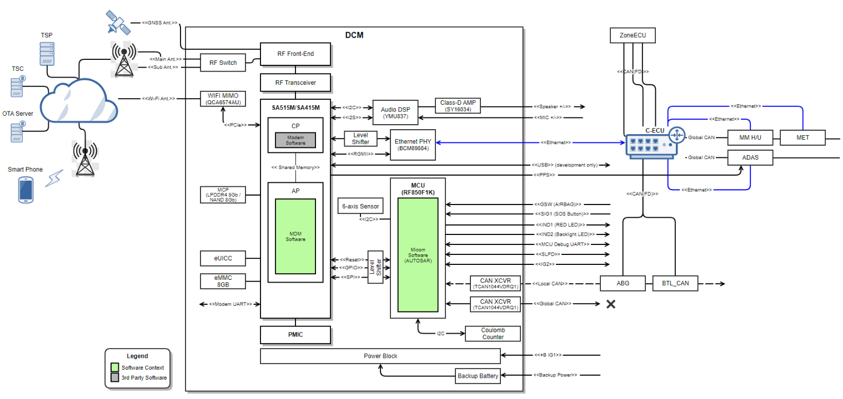
Figure 1: Overall system architecture

Software Architectural
Toyota 24DCM SU software has the layered architecture. Application Layer, Tiger Framework, TMC Specific Framework, Linux Libraries & Utilities and TMC software provided by OEM. (i.e. Toyota Common Software)
- Application Layer has the Regional (destination) Applications that shall meet Toyota requirements by using LGE Tiger and TMC Framework.
- Tiger Framework is LGE Telematics Framework. Some modules in this layer are added or updated to meet OEM requirements.
- TMC Framework is for Toyota specific requirements.
- Although one from an LGE software point of view, these two frameworks are conceptually considered as DCM PF and DCE PF by OEM.
- DCM PF API and DCE PF API are the abstraction layers that provide functionalities of DCM to support TMC software.
- The green software blocks (several binaries) are provided by TMC and uses the PF API.
- DCE API in the green blocks is the layer that provide functionalities of DCE to support TMC software and Tier-1 software (i.e. Regional Application). This is software architecture design of the project.
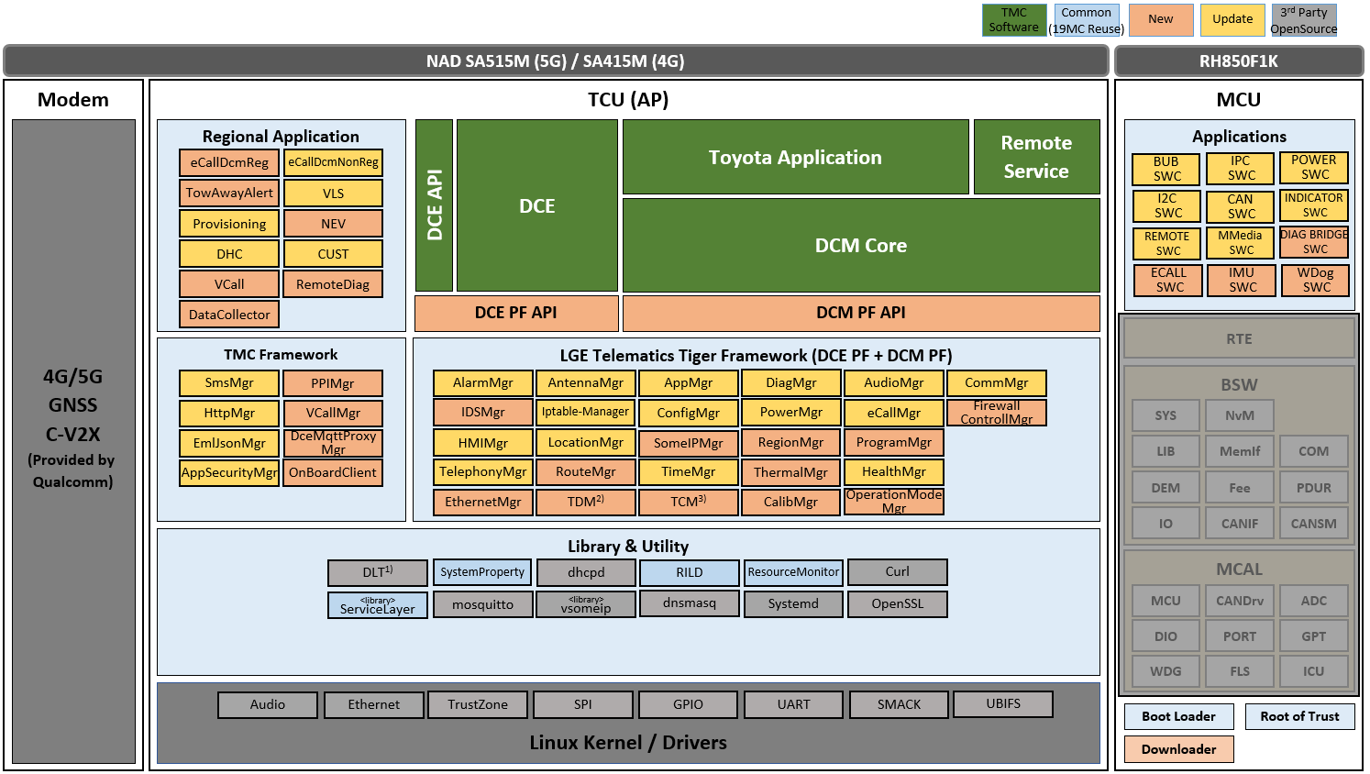
Figure 2: Software architectural design
Applications use provided service APIs to make the service request. Application can receives the response as return value or output parameters if it is a synchronous call. Otherwise, if service call is asynchronous, application can receive response inform of a callback.
Framework services provide other services and application API for making request and receive the response over Binder IPC.
AP communicates with MCU over SPI and UART interfaces.

Background
Configuration Service receives read/write requests from Toyota Applications (Remote Service, DCE, DCM Core, via PFAPI) and from other LGE Telematics Tiger Framework services, all communicating over Binder IPC. Configuration Service persists the configuration data to a File I/O based JSON database.
The main role of Configuration Service is to manage power-related information and provide this information to requested apps/services.
Power-related information is below:
- Storing the data for other modules.
- Retaining the data across board reboots.
- Providing query, add, update, and remove data APIs.
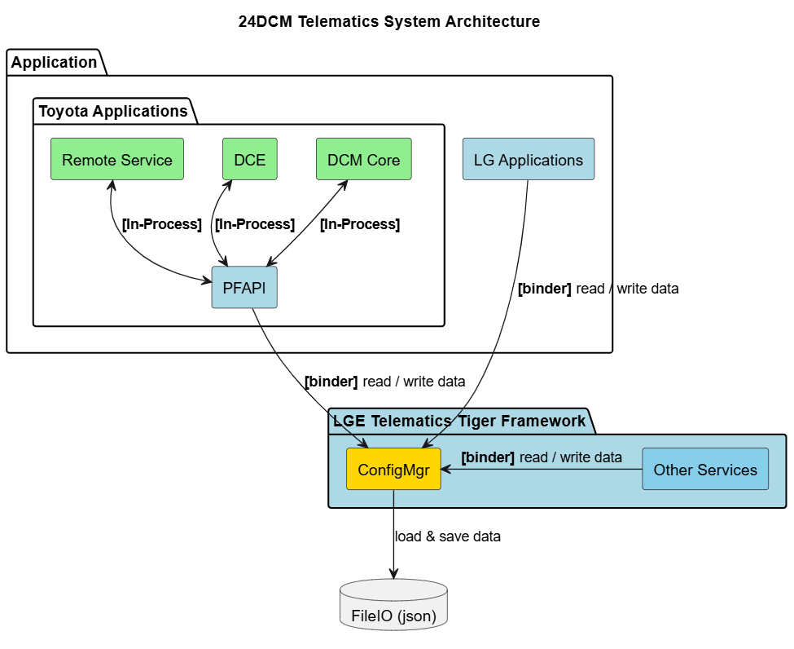
Figure 3: Configuration Service component interaction diagram in 24DCM SU architecture

Configuration Service includes the core and the variant parts. It describes components of the Configuration Service and their relationship.
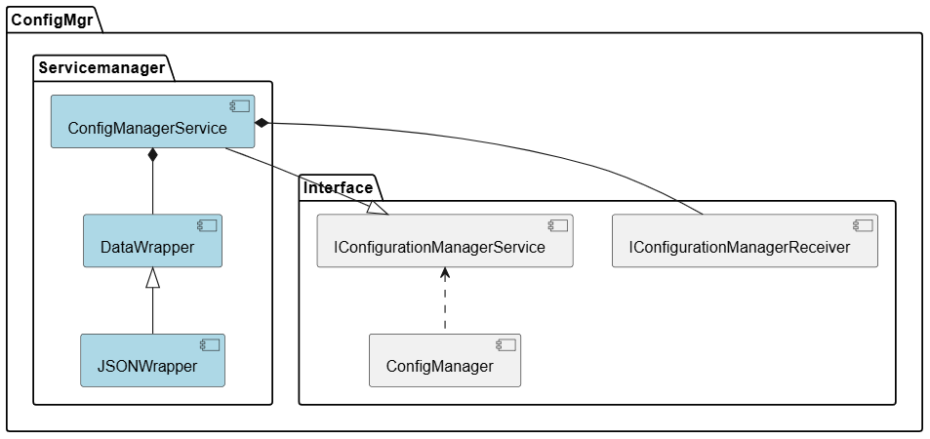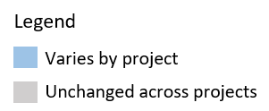
Figure 4: Configuration Service components

Problem Defined

Functional Requirements
Boot-up performance
When DCM is started in the following cases, DCM PF shall make DCM PF API available in less than the following processing time:
• Boot-up from power supply: Less than 50 seconds
• Boot-up from STANDBY mode: Less than 2 seconds
Configuration Writing
Configuration data retain after reboot

Problem Identification

Problem Description
Problem #1 – Boot Performance:
- Starting point (spec): Boot-up performance from power supply should be less than 50 seconds.
- Actual: System boot up takes ~53 seconds.
- Action: Reduce the booting time of all modules – including Configuration Service.
- For Configuration Service specifically: it takes a lot of time to read and load the entire database file when initializing the service (~1.5s).
- Internal goal: Reduce Configuration Service boot up time to ~1s.
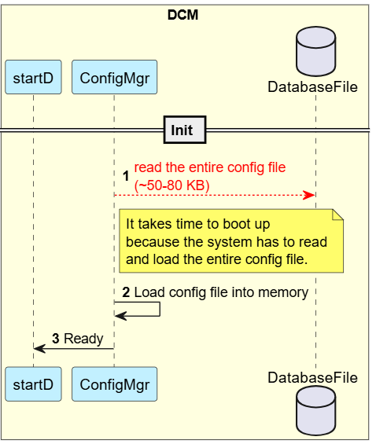
Figure 5: Boot latency problem
Problem #2 – Data Reliability:
- Scenario: Configuration Service is updating the file when a power loss/crash occurs.
- Expected: The database is consistent.
- Actual: The database file is corrupted, and all data is lost.
Root cause: When only one key changes, the service rewrites the entire DB file, causing high I/O and poor performance. If power is lost or a crash occurs during the write, the file can become corrupted.
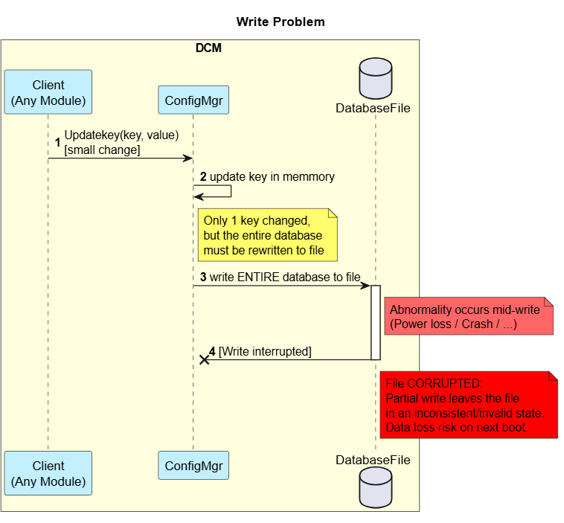
Figure 6: Write problem – sequence diagram (power loss/crash)
This issue has also occurred across related projects:
- 24DCM project: Configuration database file was interrupted after plug-in/out
- JRL project: Config DB / Calib DB were corrupted by Diagnostics reset (11 01) command

Problem Analysis
Current database structure: JSON file
- The database is a JSON file, storing data in “key: value” format.
- Contains ~800 keys.
- File size ~50KB.
- All data is loaded when the service is initialized, which takes 1.5 seconds.
- When a single key is updated, all data has to be rewritten, which takes ~40ms.

{
"kvs": {
"SERVICE_FLAG_SETTINGS": "00000000",
"DFInformation": "0000000000000000",
"CCThresholdActive": "1388",
"OTThresholdActive": "32A0",
"AutoADFSuppressDistLimit": "01",
"AutoADFSuppress": "00",
"OperationInformation": "00000",
"ActivationInfo": "0000",
"LEDBrightness": "02",
…
…
}

Figure 7: Detailed sequence analysis of processing delays

Current Implementation Problem:
- Creates a backup database and writes to both files each time the data is updated, checksums the update.
- At initialization, loads both files, checks if a file is corrupted, and recovers the corrupted file.
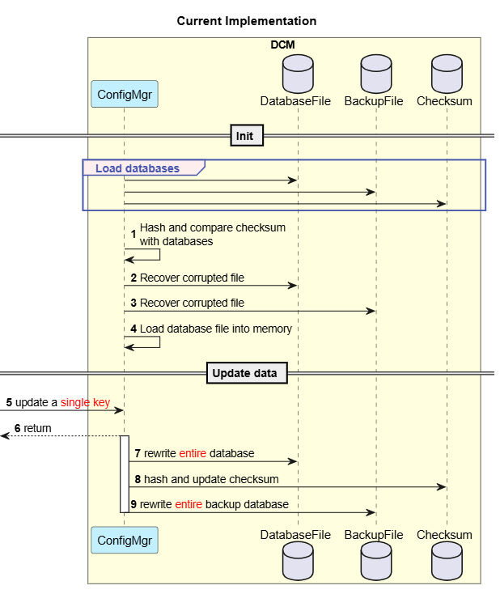
Figure 8: Current implementation (backup + checksum) – sequence diagram

Quality Attributes
The following quality attributes were carefully considered and prioritized while improving Configuration Service. These attributes guided the architectural decisions and solution selection to ensure the new database structure handing meets both functional requirements and non-functional expectations:
Quality Attribute | Priority | Description
Performance | High | System must meet timing requirements for critical operations with consistent response times.  Configuration Service boot time reduced from ~1.5s to under ~1s. Write a single key time reduced from ~40ms to under ~5ms.
Reliability | High | Ensure the data will not be lost when an abnormality occurs (power loss, crash, …).
Simplicity | Medium | Balance implementation complexity with operational reliability for mission-critical systems.
Table 1: Quality Attributes

Architecture Alternatives

Database structure alternatives for Configuration Service
Based on the problems identified above, Configuration Service requires a fundamentally different database structure to eliminate the full-file read/rewrite pattern that causes both the boot latency and the data-corruption risk. Three alternative proposals were evaluated, each addressing the core issue through a different database mechanism.

Proposal 1 – LSMDB mechanism (Log-Structured Merge Database)
The database is stored as a binary file composed of an Index block (keys and their offsets) and a Data section (keys and values). Every time data is updated, the change is appended to a WAL log file (wal.log, max 4KB) instead of being written directly to the database file, and the update is also kept in an in-memory MemTable (max 4KB). Only the wal.log and Index block are loaded at initialization. When the MemTable or WAL log reaches 4KB, the MemTable is merged with the Data section into a new database file, and the old database and WAL log are cleared.
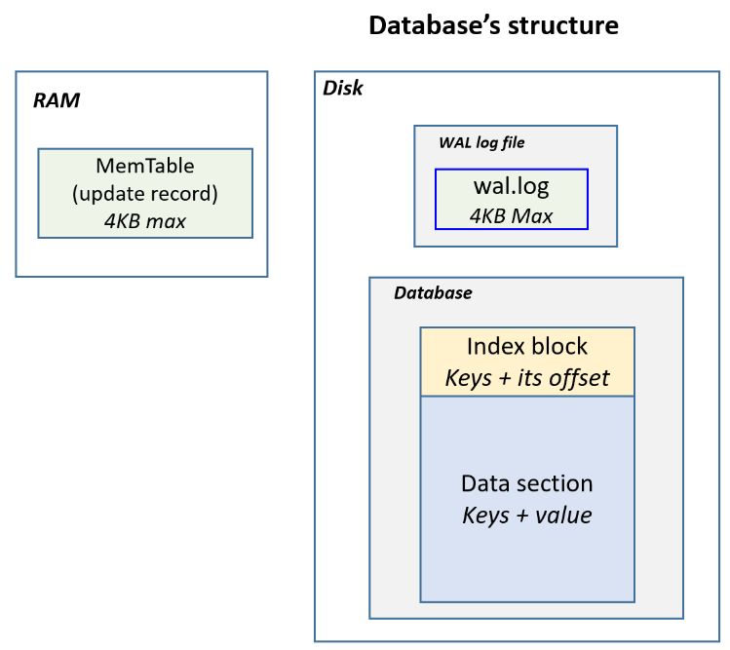
Figure 9: Log-Structured Merge database structure
Key Characteristics:
- At initialize time, Configuration Service only need to load the wal.log and Index Block.
- When update value for a key, the Configuration Service appends to the wal.log file and update the Memtable variable.
- When the Memtable or wal.log reach 4KB, Configuration Service will merge the Memtable and current data, save it as a new database file, then clear the wal.log file and deletes the old database file.
- Reading: when reading a key, the Configuration Service will read from Memtable first, if the Memtable does not contain the key, it will ready from database file
Sequence Diagram:
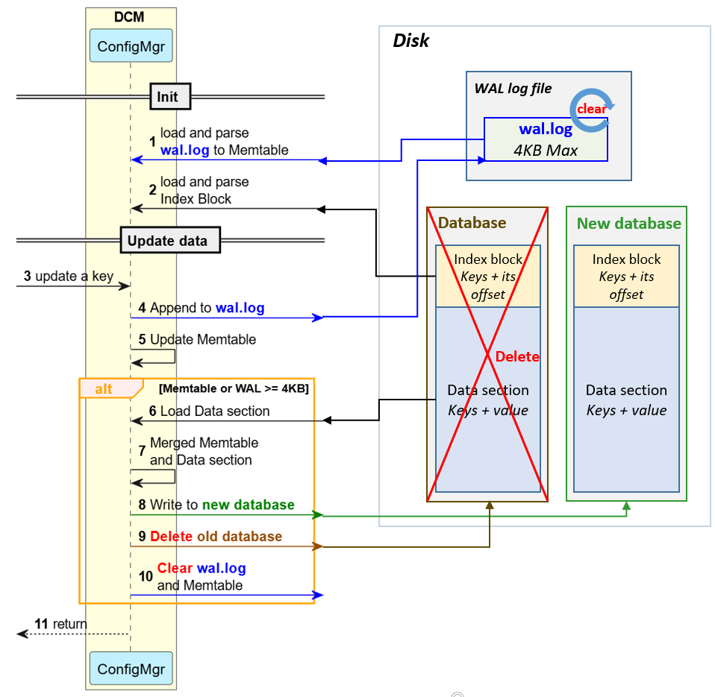
Figure 7: Proposal 1 – LSMDB mechanism sequence diagram
Advantages:
- Reliability: If an abnormality occurs during writing to new database, the wal.log and the old database still remain.
- Performance: Boot time is reduced from ~1500ms to ~1100ms; updating a single key is reduced from ~40ms to ~2ms.
Disadvantages:
- Simplicity: High implementation complexity due to introducing a new database engine.

Proposal 2 –Lightning Memory-Mapped Database mechanism
The database is a binary file divided into fixed-size blocks (4KB each), which can be accessed individually without opening the entire file. A header block addresses the blocks that contain data. Only the header block is loaded at initialization. Updates use copy-on-write: the block containing the target key is located, a copy of that block is created and updated, the copy is written to disk, and finally the header block is updated and written to disk to point to the new block.
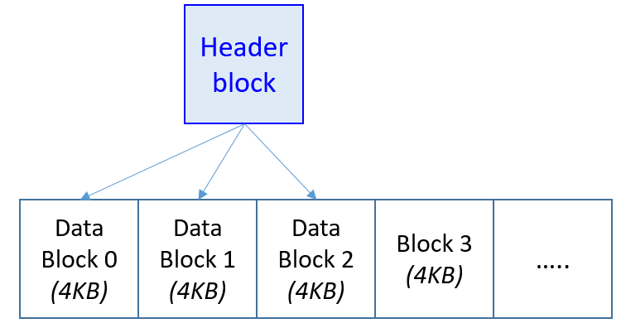
Figure 81: Proposal 2 – LMDB database structure

Key Characteristics:
- Only the header block is loaded at initialization.
- Updates use copy-on-write: the block containing the target key is located, a copy of that block is created and updated, the copy is written to disk, and finally the header block is updated and written to disk to point to the new block.
Sequence Diagram:

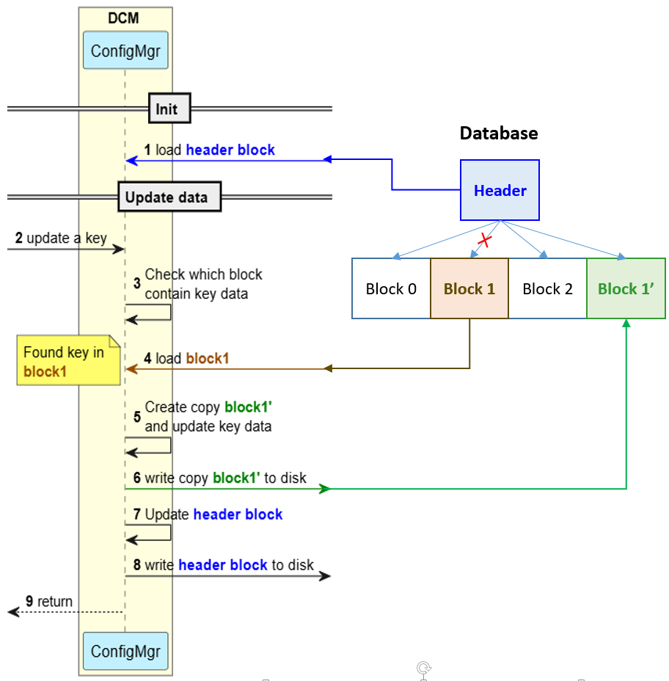
Figure 92: Proposal 2 – LMDB mechanism sequence diagram
Advantages:
- Reliability: If an abnormality occurs, the old data block still remains untouched
- Performance: Boot time is reduced from ~1500ms to ~850ms; updating a single key is reduced from ~40ms to ~4ms.
Disadvantage:
- Simplicity: Medium implementation complexity to handle the new database format.

Proposal 3 – SQLite
Similar to LMDB, the database is a binary file divided into 4KB blocks, with a header block addressing which blocks are data blocks; in addition, a WAL log file (max 4KB) is used to protect writes: every update is appended to wal.log instead of being written directly to the database file. Only the header block is loaded at initialization.

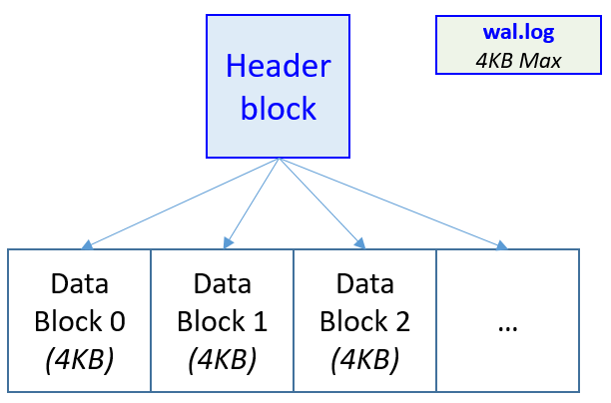
Figure 103: Proposal 3 – SQlite database structure
Key Characteristics:
- Start with a fixed number of threads (e.g., 2 threads) as baseline thread pool
- Performance-based scaling: Auto-create additional threads when individual thread processing time exceeds threshold
- Automatic scale-down: Reduce thread count to baseline after a certain period of inactivity to optimize resource usage
- Built-in hang detection and recovery mechanisms for fault tolerance
- Threshold-based monitoring for thread performance degradation
Sequence Diagram:

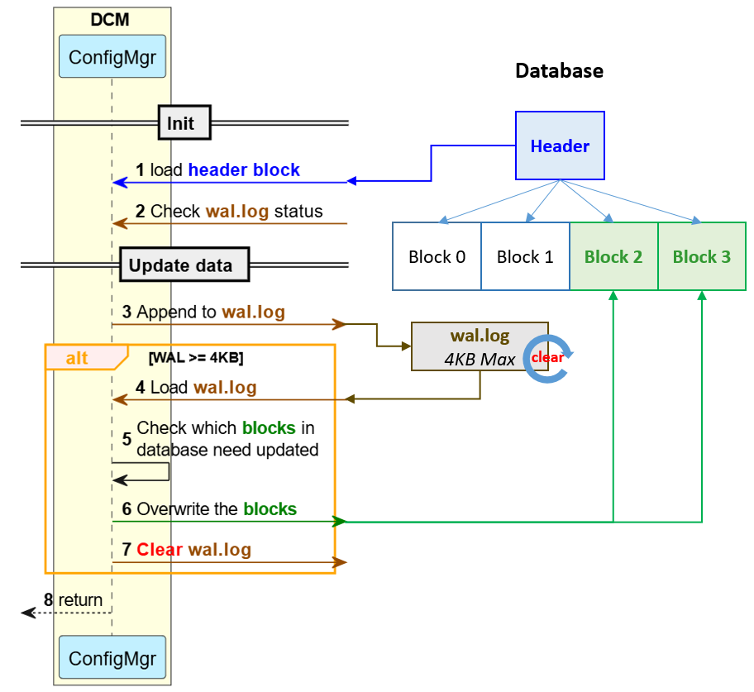
Figure 114: Proposal 3 – SQLite mechanism sequence diagram

Advantages:
- Reliability: If an abnormality occurs, the wal.log and the old database still remain.
- Performance: Boot time is reduced from ~1500ms to ~1200ms; updating a single key is reduced from ~40ms to ~2ms.
Disadvantage:
- Simplicity: Medium implementation complexity to handle the new database format.

Comparison and decision
Consider the table to see the comparison of the designs:
Criteria | Priority | Current implementation | Proposal 1 Log-Structured Merge | Proposal 2 Lightning Memory-Mapped | Proposal 3 SQLite
Reliability | High | High  (File backup) | High  (Write-Ahead Log) | High  (Copy on write) | High  (Write-Ahead Log)
Performance (booting) | High | Low  (~1500ms) | Medium  (~1100ms) | High  (~850ms) | Medium  (~1200ms)
Performance (writing) | High | Low  (~40ms) | High  (~2ms) | High  (~4ms) | High  (~2ms)
Simplicity | Medium | High | Low | Medium | Medium
Table 2: Comparison of database structure proposals
Key Decision Factors:
- Performance: Both the booting time and the writing time of Proposal 2 (LMDB) are the best among the three proposals.
- Reliability: All three proposals ensure the data will not be lost when an abnormality occurs (power loss, crash,…).
- Simplicity: A complex implementation is acceptable given Configuration Service’s mission-critical nature, where reliability and performance outweigh simplicity.
- Balanced Trade-offs: Good performance + reliability + adaptive efficiency outweigh the complexity concerns.
- Selected proposal 2: LMDB – Lightning Memory-Mapped Database

Design for Dynamic Thread Pool
Having selected LMDB as the database mechanism, three integration design proposals were evaluated for how Configuration Service should interact with the LMDB open-source library. The legend below applies to the diagrams in this section: new components are being introduced, existing components are unchanged, and the LMDB component is an open-source library.

Proposal 1: Direct Integration
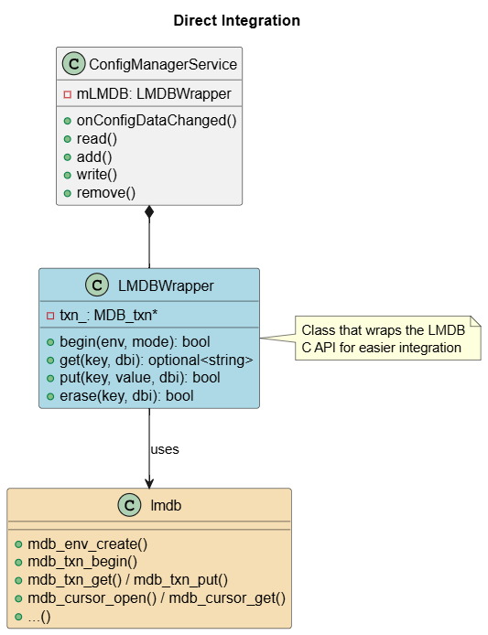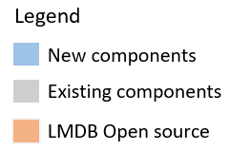
Figure 125: Design for LMDB Proposal – Direct Integration class diagram
ConfigManagerService directly holds a thin LMDBWrapper that wraps the LMDB open-source library APIs (mdb_env_create, mdb_txn_begin, mdb_txn_get/put, mdb_cursor_open/get,…). There is no abstraction layer between ConfigManagerService and the database operations.

Proposal 2: Generic Interface Design
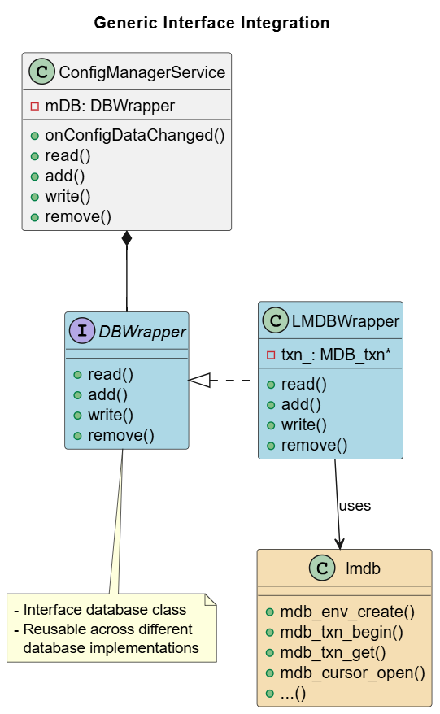
Figure 136: Design for LMDB Proposal - Generic Interface
This proposal introduces a generic DBWrapper interface between ConfigManagerService and the database library. ConfigManagerService holds a reference to DBWrapper (mDB: DBWrapper) instead of a concrete class, and LMDBWrapper is one concrete implementation of DBWrapper that internally invokes the lmdb open-source library APIs. ConfigManagerService therefore depends only on the abstraction (DBWrapper), not on LMDB-specific details.

Proposal 3: Command Pattern Integration
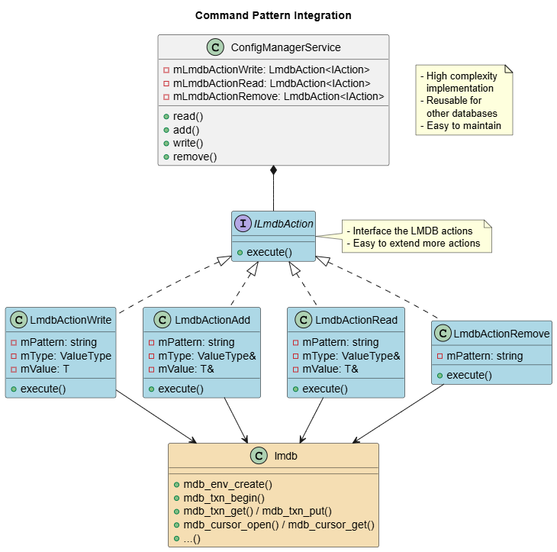
Figure 147: Design for LMDB Proposal - Command Pattern Integration class diagram
This proposal implements each CRUD operation (read, add, write, remove) as a concrete command class (LmdbActionRead, LmdbActionAdd, LmdbActionWrite, LmdbActionRemove) implementing the ILmdbAction interface with an execute() method. ConfigManagerService holds one instance of each command (mLmdbActionWrite, mLmdbActionAdd, mLmdbActionRead, mLmdbActionRemove) and delegates each operation to the corresponding command object, which internally calls the LMDB library.

Comparison and decision
Criteria | Direct Integration  (Proposal 1) | Generic Interface Integration  (Proposal 2) | Command pattern  (Proposal 3)
Reusability | Low (LMDB-specific only) | High (works across databases) | High (works across databases)
Simplicity | High  (simple integration) | High  (simple integration) | Low  (High complex implement)
Maintainability | Medium (mixed concerns) | Medium (mixed concerns) | High (separated concerns)
Table 3: Comparison of LMDB design proposals
Decision Rationale:
When using a small library like LMDB, design simplicity should be prioritized over maintainability.
Key Decision Factors:
- Reusability: Reusable across different database implementations
- Simplicity: Simple implementation of the database interface and LMDB integration
- Selected Design: Generic Interface Integration (Proposal 2)

Implementation and Verification

Implementation
The selected solution – LMDB (Lightning Memory-Mapped Database) integrated via the Generic Interface Integration design – was implemented in Configuration Service, replacing the JSON file with checksum-based backup mechanism. Configuration Service now depends only on a generic DBWrapper interface (read/add/write/remove), with LMDBWrapper providing the concrete implementation and internally invoking the LMDB open-source library APIs (mdb_env_create, mdb_txn_begin, mdb_txn_get/put, mdb_cursor_open/get,…). At initialization, only the LMDB header page is loaded (instead of the entire ~50KB JSON file), and each update uses LMDB’s copy-on-write mechanism instead of rewriting the entire database.

Static view
ConfigManagerService depends on the DBWrapper interface, which is implemented by the concrete LMDBWrapper component. LMDBWrapper is the only component that talks to the LMDB open-source library, which in turn persists data into the on-disk key-value data base.

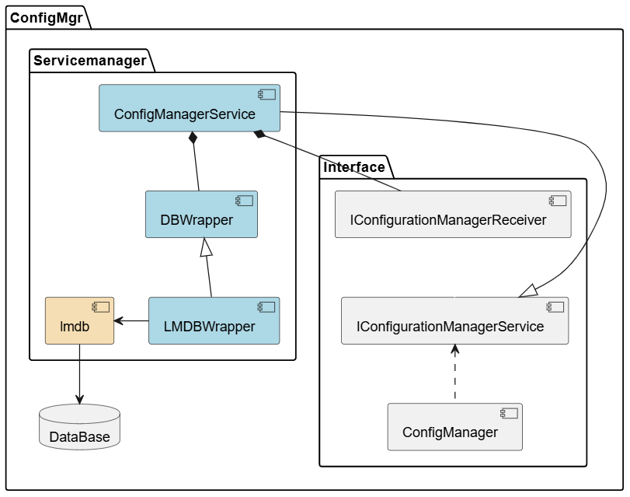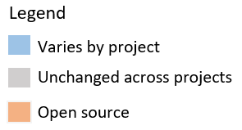
Figure 158: Configuration Service components after implementation

LMDBWrapper is the concrete class that implements the DBWrapper interface selected in section 4.2, exposing the same read/write/add/remove operations. Internally, it wraps the LMDB C API (MDB_env, MDB_dbi) and stores each value as a type-tagged JSON blob under a JSON-pointer-style key, which adapt with current Configuration Service public API.
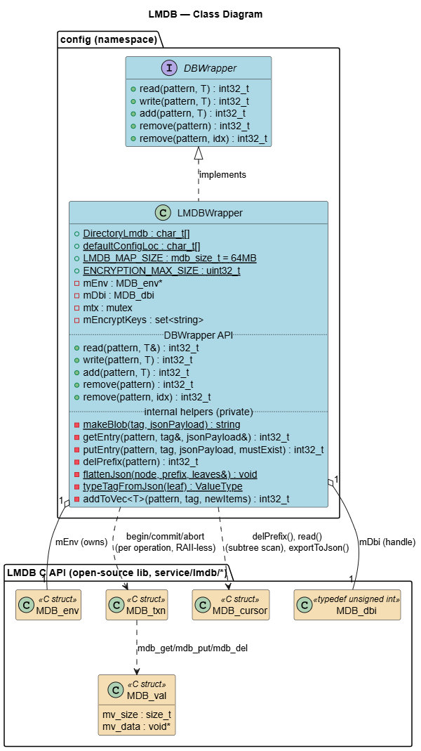
Figure 169: Class diagram

Dynamic view
Initialization algorithm diagram:
On first boot (empty database), default configuration entries are populated into LMDB; otherwise initialization simply opens the existing environment and database.
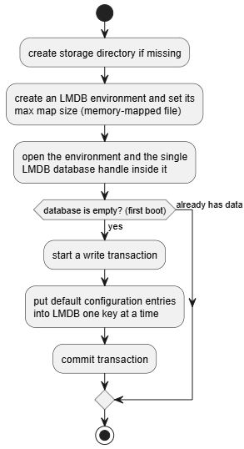
Figure 20: Dynamic Initialization flow algorithm

Read algorithm diagram:
Supports both exact-key lookup and prefix/subtree lookup, combining all matching entries into a single result.
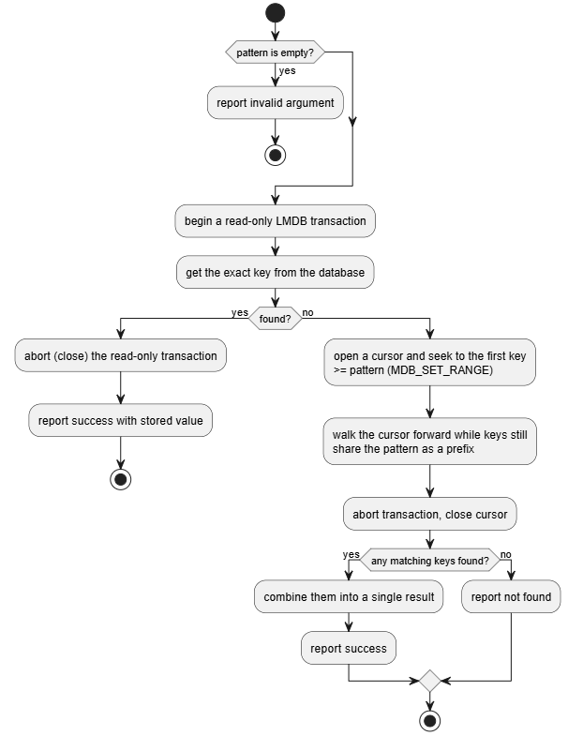
Figure 21: Dynamic read flow algorithm

Write algorithm diagram:
Only updates a key that already exists; relies on LMDB’s copy-on-write so an update never mutates in place.
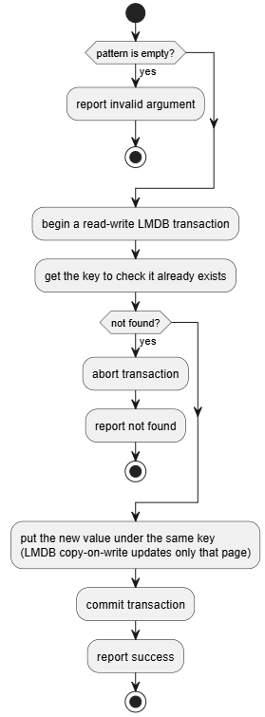
Figure 22: Dynamic write flow algorithm

Add algorithm diagram:
Behaves as an upsert, and additionally appends to an existing array value rather than overwriting it.
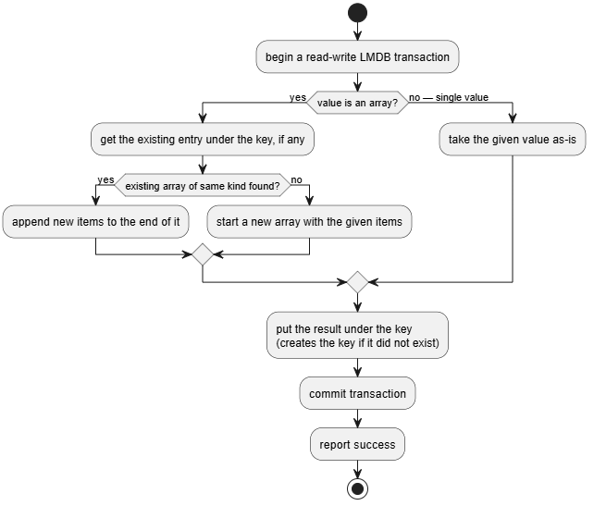
Figure 23: Dynamic add flow algorithm

Remove algorithm diagram:
Supports removing a single array element by index, or an entire key/subtree when no index is given.
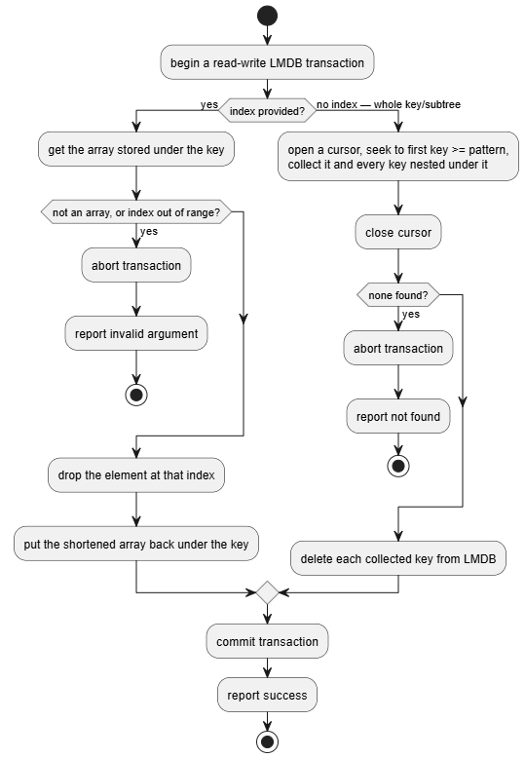
Figure 24: Dynamic remove flow algorithm

Verification
A stress test measuring 50 boot cycles was performed to compare the current implementation and the new LMDB-based implementation
Metric | Current Implementation | LMDB Implementation | Improvement
Configuration Service booting time | ~1.474s (avg) | ~0.832s (avg) | ↓44%
Writing time (single key) | ~38.1ms (avg) | ~3.7ms (avg) | ↓90%
Table 4: Testing result – average of 50 measurements

Booting time
A stress test measuring 50 boot cycles was performed to compare the current implementation and the new LMDB-based implementation for booting time.
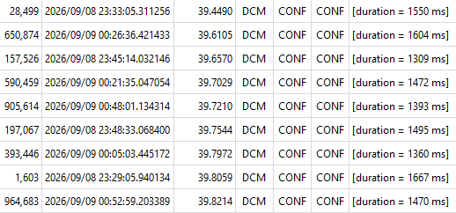
Figure 25: Configuration booting time with current implementation

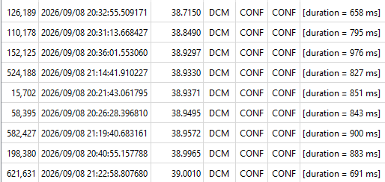
Figure 26: Configuration booting time with LMDB implementation

Figure 27: Configuration booting time testing chart

The results show that the average Configuration Service booting time was reduced by ~44%, meeting the internal goal of reducing the boot time to under ~1 second

5.2.2 Writing time time
A stress test measuring 50 boot cycles was performed to compare the current implementation and the new LMDB-based implementation for a single key writing time.
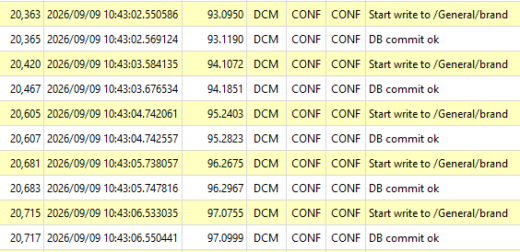
Figure 28: Writing time a single key with current implementation

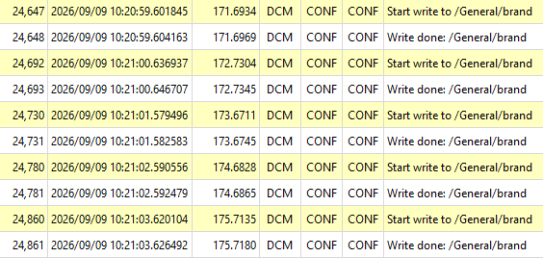
Figure 29: Writing time a single key with LMDB implementation

Figure 30: Configuration writing time testing chart

The average time to write (update) a single key was reduced from ~40ms to ~4ms, a ~90% improvement, which is well within the target of under ~5ms defined in the Quality Attributes.

Quality Attributes result

Quality Attribute | Priority | Description | Result
Performance | High | Improved ConfigMgr booting time from ~1500ms to ~850ms. Improved write key time from ~40ms to ~4ms. | ✅
Reliability | High | The data remains when an abnormality occurs. | ✅
Simplicity | Medium | New implementation is relatively complex but acceptable. | ❌
Table 5: Quality Attributes result

Conclusion
The evaluation of three database mechanisms (LSMDB, LMDB, and SQLite) determined that LMDB, integrated through a Generic Interface Integration design, provides the best balance of reliability, performance, and acceptable implementation complexity for Configuration Service. Verification results confirm that both the boot-up bottleneck (Problem #1) and the data-corruption risk under power loss/crash (Problem #2) are resolved, with Configuration Service booting time reduced by ~44% and single-key write time reduced by ~90%, while the data remains protected against abnormal power loss or crash events.

Plan to apply:
November 2026: Apply the selected solution (LMDB with Generic Interface Integration) to the Configuration Manager Service in the Toyota 24DCM (SU) and 26BEV projects.

